Section 3.2 — Maternal Age by Birth Order

Figure 2: Maternal Age by Birth Order
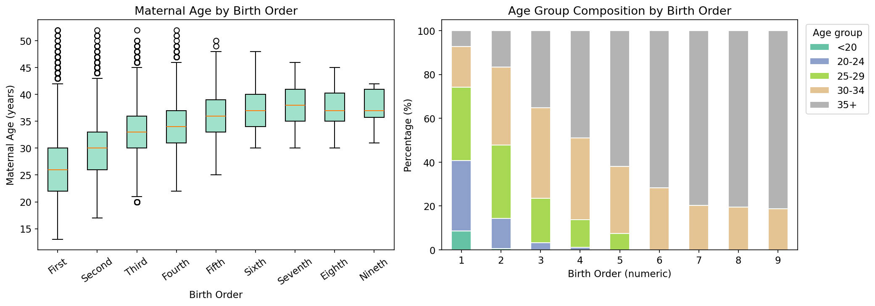

Table 1: Maternal Age Descriptive Statistics by Birth Order
Birth Order | Parity | N | Mean | Median | Std Dev | Min | Max | Q1 | Q3
First | 1 | 128,521 | 26.27 | 26.00 | 5.31 | 13 | 52 | 22.00 | 30.00
Second | 2 | 110,651 | 29.83 | 30.00 | 4.80 | 17 | 52 | 26.00 | 33.00
Third | 3 | 49,063 | 32.76 | 33.00 | 4.48 | 20 | 52 | 30.00 | 36.00
Fourth | 4 | 10,845 | 34.32 | 34.00 | 4.35 | 22 | 52 | 31.00 | 37.00
Fifth | 5 | 2,505 | 35.80 | 36.00 | 4.33 | 25 | 50 | 33.00 | 39.00
Sixth | 6 | 503 | 37.29 | 37.00 | 3.98 | 30 | 48 | 34.00 | 40.00
Seventh | 7 | 138 | 38.01 | 38.00 | 3.96 | 30 | 46 | 35.00 | 41.00
Eighth | 8 | 36 | 37.53 | 37.00 | 3.97 | 30 | 45 | 35.00 | 40.25
Nineth | 9 | 16 | 37.56 | 37.00 | 3.37 | 31 | 42 | 35.75 | 41.00

Note: N = number of births. Q1/Q3 = 25th/75th percentile of maternal age.

Table 2: Age Group Composition (%) by Birth Order
Birth Order | <20 | 20-24 | 25-29 | 30-34 | 35+
First | 8.72 | 31.98 | 33.42 | 18.57 | 7.31
Second | 0.67 | 13.65 | 33.41 | 35.71 | 16.55
Third | 0.00 | 3.31 | 20.26 | 41.20 | 35.23
Fourth | 0.00 | 1.17 | 12.68 | 37.17 | 48.98
Fifth | 0.00 | 0.00 | 7.43 | 30.70 | 61.88
Sixth | 0.00 | 0.00 | 0.00 | 28.23 | 71.77
Seventh | 0.00 | 0.00 | 0.00 | 20.29 | 79.71
Eighth | 0.00 | 0.00 | 0.00 | 19.44 | 80.56
Nineth | 0.00 | 0.00 | 0.00 | 18.75 | 81.25

Note: Values represent the percentage of mothers in each age group within each birth order category.

